

**ANJUMAN KHAIRUL ISLAM’s**

**POONA COLLEGE OF ARTS, SCIENCE & COMMERCE**

**Camp, Pune - 411001.**

**CERTIFICATE**

This is to certify that the project entitled

RESTAURANT BILLING SYSTEM

Has been partially completed successfully by “Khan Aasif Bismillah & Tasdiq Shaikh “, Towards partial fulfillment Bachelor Of Business Administration(Computer Application)

in Commerce Department from University of Pune, for the academic year 2010-2011.

**Vice Principal Internal Examiner**

**Project Guide External Examiner**

**ACKNOWLEDGEMENT**

* I heartily wish to take this opportunity to express my gratitude to my teachers and friends for how they have helped me a lot in completing my project.
* I am very grateful to my lecturer, Faheemuddin ahmedf or his explainations and constant guidance throughout the project.
* I would also like to give thanks to our **H.O.D &Vice Principal, Prof. Khalid Zaheer Sir** for his valuable support, help and guidance whenever needed.
* I am very grateful to my lab instructor whose suggestions helped me a lot while project work in progress and I am also grateful to the non-teaching staff for helping me in laboratory in various ways.
* I would like to extend my gratitude to those friends whose knowledge and time had been given to help me in different ways.

*“Khan Aasif Bismillah & Tasdiq Shaikh”*

**INDEX**

**1. INTRODUCTION**

* + Company Profile
  + Introduction to System
  + Scope of System
  + Proposed System

**2**. **ANALYSIS**

* + Fact Finding Techniques
  + Feasibility Study
  + Hardware and Software Requirements

**3**. **SYSTEMDESIGN**

* + ER Diagram
  + Context Level Diagram
  + Dataflow Diagram
  + File Design
  + Data Dictionary
* **4**. **FORMDESIGN**
* **5**. **REPORTS**
* **6**. **ADVANTAGESANDLIMITATIONS**
* **7**. **FUTUREENHANCEMENT**
* **8**. **BIBLIOGRAPHY**

**(1) INTRODUCTION**

1. **Company Profile :**

The software is designed keeping in mind the day to day basic requirements of any restaurant business. This project has been designed keeping in mind the flow of activities of the business.

The day to day activities of restaurant involves making billing, creating orders, Managing daily database like ADD, Update or Delete Items etc.

The Restaurant Billing System is user friendly and low cost solution to their needs.

This system can also be used by untrained staffs.

1. **Scope of the System :**

The main aim of proposed system is to minimize the manual overheads like calculating total cost of customers bill on calculator manually. The proposed system has been designed according to these problems.

Proposed system is very easy to use, which in return will minimize the overhead of training of the end user of software. Proposed system has facility to generate reports which will help the owner of restaurant to make future deciscions.

1. **Existing System :**

Nowdays, It is very tedious job to manage the day to day activities of the restaurant. The activities like creating order, managing the rates of items and billing the customer is very time consuming.

There is a need to build a system which can manage all these activities on the go.

And kepping the focus on the core business.

1. **Proposed System :**

Proposed System will help to overcome disadvantages of the present system.

All undesirable features have been removed, Efforts have been taken to minimize the list of menus so that the system becomes more user-friendly.

Proposed System comes with integration of different modules, Separate module has been created for different purposes. The system can be accessed by a user.

It contains main modules Generating Bill, Managing Categories, Updating rates of Existing rates, Generating the rates of item.

**(2)ANALYSIS**

1. **Fact Finding Techniques :**

Fact finding techniques are concerned with finding the requirements of the user. System is to be developed in such a way that it should satisfy the user needs efficiently within the limitations of the developer.

Understanding the user requirements within the framework of the organization objectives and the environment in which the system is installed is very important.

After studying the system, certain fact comes into picture those are manually Entering the data, creating the orders, Report generation patterns etc. In computerization of the above software’s the user will generally demand more UI Friendly packages for easier operations and protect the data from un-authorized access.

Report Generation and designing of reports should be simple i.e with minimal graphics for decreasing the cost of operations.

1. **Feasibility Study :**

**1.) Economic Feasibility**:

RESTAURANT BILLING SYSTEM has been designed keeping in mind the requirements of organizations. R.B.S are generally modified according to Restaurant requirements. Efforts has been made to make software more qualitative rather than quntative.

Restaurant Billing System requires MS ACCESS as a backend, which can be purchased at 5000+.

2.**) Technical Feasibility :**

Now days every business organization have availability of wireless connection within the office premises therefore, thesystem confines to the present technical configurations, there is no need to arrange for special configuration. This system works well with present configurations which the organization has, which makes this system more cost saving.

**3.) Operational Feasibility:**

No special sessions are required to educate the staff regarding the use of this software. Software is user-friendly. No cost is required to maintain this system. This System scores well in terms of maintainability, usability, disposability, sustainability, affordability and others. The system serves well for the intended purposes.

1. **Hardware and Software Requirements:**

**Hardware Requirements :**

|  |
| --- |
| Ram : 512MB or greater |
| Processor : Pentium 4 onwards ( dual core can be advantage ) |
| Printer : Monochrome or Color Printer |

**Software Requirements:**

|  |
| --- |
| Operating System : Windows XP or greater |
| Backend : MS ACCESS (2000 or greater) |
| Front End : VB.NET |

**(3) SYSTEM DESIGN**

**1.ER DIAGRAM:**

1

Customer

Selects

To

Items

m

1

Bill

For

1

Admin

Order

1

Generates

**2.Context Level Diagram :**

**0.0**

Save Bill Details

Bill Details

Bill

Admin

On demand Report

Request Report

Admin

Admin

**3.FIRST LEVEL DATA FLOW DIAGRAM**

Generate Bill

Admin

Admin

**1.0**

Save Bill Details

Bill Details

Bill

Admin

Bill Generated

**2.0**

Add,Update,Delete Details to Category

Food_Type

Admin

Save Details

Food_Item

Admin

**3.0**

Save Details

Add,Update,Delete Details to Food_Item

**File design**

1. Food_Item

|  |  |  |
| --- | --- | --- |
| **FIELD NAME** | **DATA TYPE** | **CONSTRAINT** |
| FI_ID | Int | Primary Key |
| Item_name | Text | Not Null |
| F_type | Text | Not Null |
| Rate | Int | Not Null |

1. Food_type

|  |  |  |
| --- | --- | --- |
| **FIELD NAME** | **DATA TYPE** | **CONSTRAINT** |
| Food_ID | Int | Primary key |
| F_type | Text | Not Null |

3 . Login

|  |  |  |
| --- | --- | --- |
| **FIELD NAME** | **DATA TYPE** | **CONSTRAINT** |
| UName | Text | Not Null |
| Password | Text | Not Null |

4. Bill

|  |  |  |
| --- | --- | --- |
| **FIELD NAME** | **DATA TYPE** | **CONSTRAINT** |
| Bill_no | Int | Not Null |
| T_no | Int | Not Null |
| Item | Text | Not Null |
| Qty | Int | Not Null |
| Rate | Int | Not Null |
| Amount | Int | Not Null |
| Total_Amount | Int | Not Null |
| Bill_Date | Date | Not Null |
| Dummy | int | Not Null |

**Data Dictionary**

1. Food_Item

|  |  |  |  |  |
| --- | --- | --- | --- | --- |
| **FIELD NAME** | **DATA TYPE** | **CONSTRAINT** | **Size** | **Spec** |
| FI_ID | Int | Primary Key | 5 | Stores Item FI_ID |
| Item_name | Text | Not Null | 40 | Stores Item Name |
| F_type | Text | Foreign Key | 25 | Stores Food Type |
| Rate | Int | Not Null | 5 | Stores Item Rates |

1. Food_type

|  |  |  |  |  |
| --- | --- | --- | --- | --- |
| **FIELD NAME** | **DATA TYPE** | **CONSTRAINT** | **Size** | **Spec** |
| Food_ID | Int | Primary Key | 5 | Stores Food ID |
| F_type | Text | Not Null | 25 | Stores Food Type |

3 . Login

|  |  |  |  |  |
| --- | --- | --- | --- | --- |
| **FIELD NAME** | **DATA TYPE** | **CONSTRAINT** | **Size** | **Spec** |
| UName | Text | Not Null | 15 | Username |
| password | Text | Not Null | 15 | Password |

5. Bill

|  |  |  |  |  |
| --- | --- | --- | --- | --- |
| **FIELD NAME** | **DATA TYPE** | **CONSTRAINT** | **Size** | **Spec** |
| Bill_no | Int | Primary Key | 10 | Store Bill no. |
| T_no | Int | Not Null | 10 | Stores Table no. |
| Item | Text | Not Null | 50 | Stores Item name |
| Qty | Int | Not Null | 5 | Stores Quantity |
| Rate | Int | Not Null | 5 | Stores Rate of Item |
| Total_Amount | Int | Not Null | 5 | Stores Total |
| Bill_Date | Date | Not Null | 10 | Stores Date |
| Dummy | int | Not Null | 10 | Store Dummy Bill No. |

**(4) FORMDESIGN**

Login screen

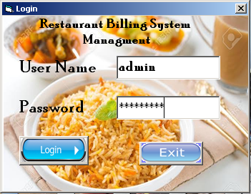

**Main MDI SCREEN**

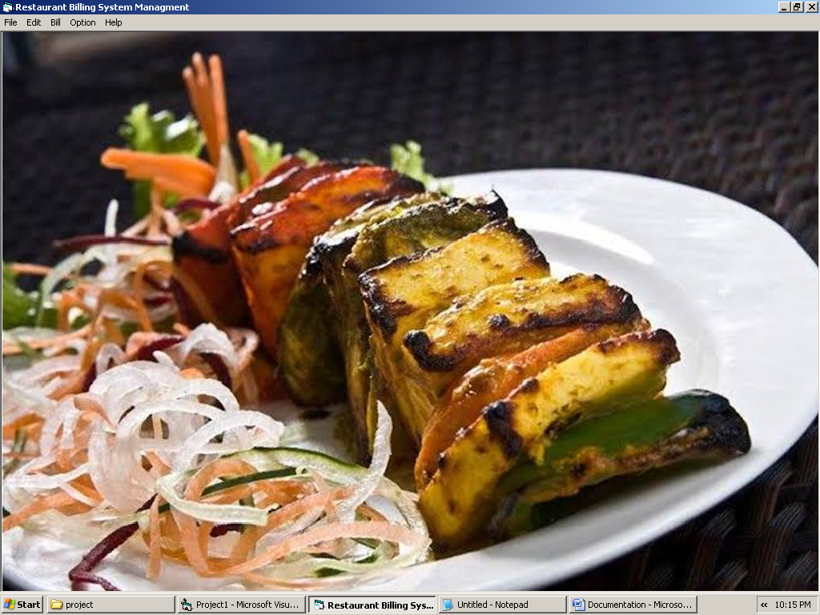

**GENRATING NEW BILL**

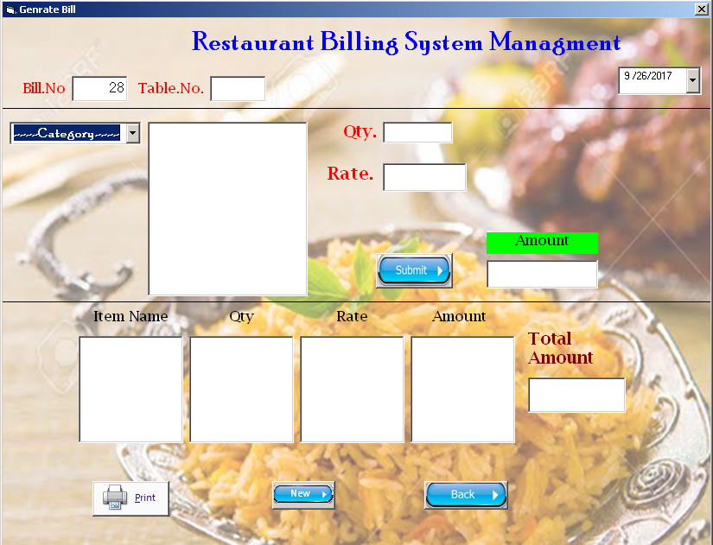

**SELECTING FOOD TYPE & ITEM TO ADD IN BILL**

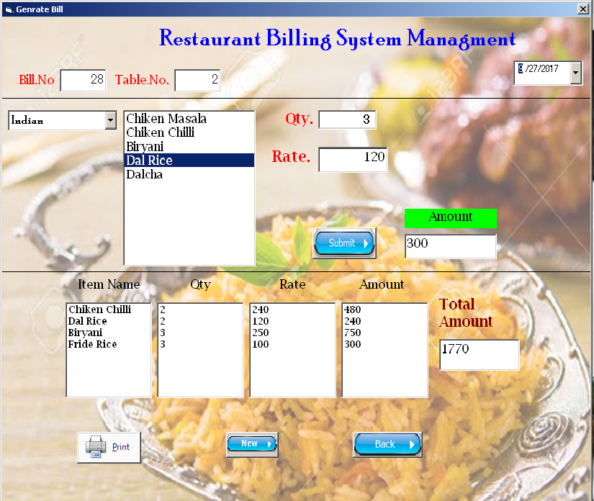

**ADDING NEW ITEM IN FOOD ITEM**

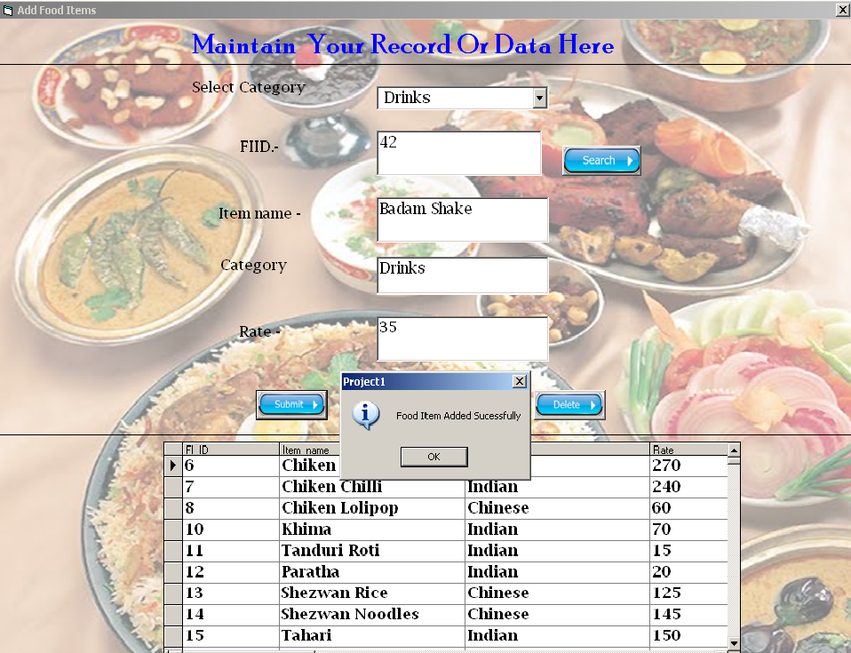

**UPDATING RATES OF EXISTING ITRM**

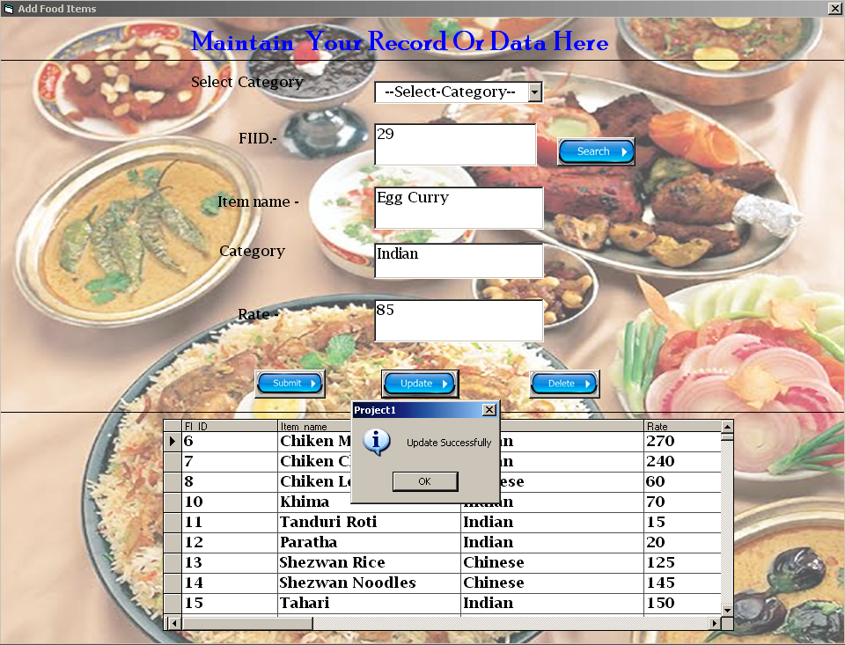

**ADDING FOOD TYPE**

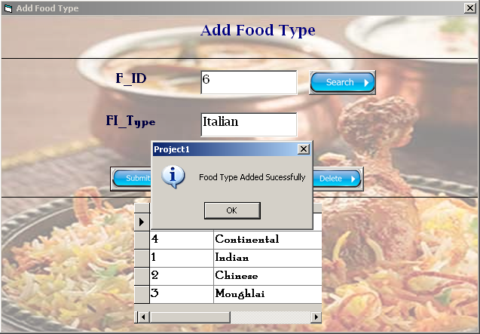

**DELETING EXISTING FOOD TYPE**

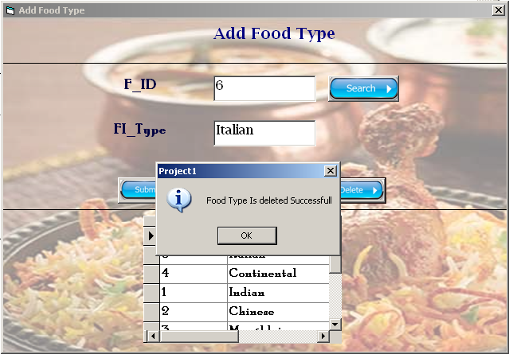

**(5) REPORTS**

**CUSTOMER BILL**

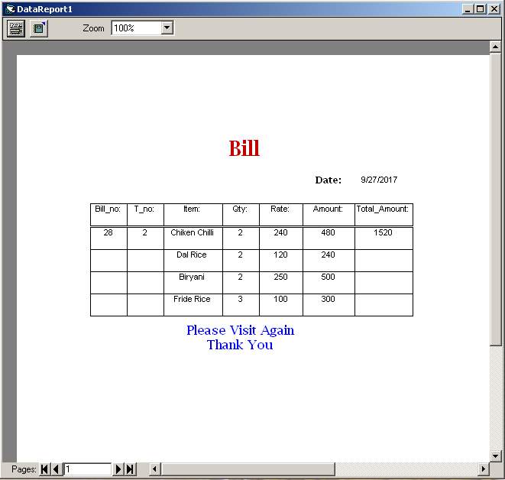

**(6) ADVANTAGES AND LIMITATIONS**

**ADVANTAGES**

1. **Integrated Modules :**

RESTAURANT BILLING SYSTEM has 3 integrated modules 1.GENERATING OR CALCULATION OF BILL 2.ADDING FOOD TYPE 3.ADDING FOOD ITEM, Which act as all in one solution for the college

1. **User Friendly :**

RESTAURANT BILLING SYSTEM does not contain ambiguous UI, It is very User Friendly and easy to use, even for first time user.

1. **Cost Cutting**

RESTAURANT BILLING SYSTEM does not require any high end RDBMS package, It runs on MS ACCESS which is readily available at 5000/- rupees.

**LIMITATIONS :**

1. **Not Online :**

RESTAURANT BILLING SYSTEM is not online which is its main limitations.

1. **Operational Cost :**

It requires MS ACCESS database which cost rs 5000/-

**(7) FUTURE ENHANCEMENTS**

**RESTAURANT BILLING SYSTEM** can be made more user friendly and reliable by implementing some additional features in our system.

1. **Online :**

Making RESTAURANT BILLING SYSTEM CRM Online will eliminate the workload of staff.

1. **Backend :**

Using MySQL or SQLite instead of MS ACCESS, As these open source database and much more reliable and efficient in handling huge amount of data. MS ACCESS lack scalability which is most important if we are dealing with huge amount of data as in case of COURIER RESTAURANT BILLING SYSTEM.

**(8)BIBILOGRAPHY**

1. Google > VB.nettutor.com
2. VB.net Black Book – Steve Holzner
3. SQL Expert Guide – Oracle
4. Software Engineering-Isabel Evans
5. MS ACCESS Tutorials
6. O’Reilly’s Designing Computer Application – Bruce Martin
7. Google > SQL Query Optimization Tutorials
8. Visual Basic – Nirali publications
9. [www.microsoft.com/MSDN](http://www.microsoft.com/MSDN) visual basic resources